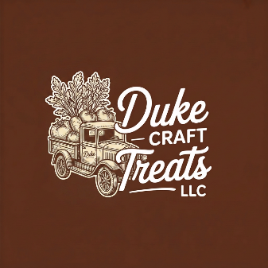

Baked Goods Price List

Cookie Cakes & Bars
Item | Price
Chocolate Chip Cookie Cake | $25
PB&J Bars-full pan | $25
Brownie-full pan | $25
Lemon Bar-full pan | $25

Muffins & Quick Breads
Item | Price
Blueberry Bread Loaf | $15
Banana Nut Bread Loaf | $15
Pumpkin Bread Loaf | $15
Mini Loaves | $8

Sourdough Bread
Item | Price
Traditional | $12
Jalapeno Cheddar | $15
Cinnamon Raisin | $15
Rosemary Asiago | $15

